|  |  |  |  |  |
| --- | --- | --- | --- | --- |
| Group |  |  |  | ACC |
| Date of Lab Work |  |  |  |  |
| Name | 1 | Pratama Aji Nur Rahman | D400154003 |
|  | 2 | Amnaduny Akhara | D400154006 |
|  | 3 | Milzam Wafi Azhar | D400154007 | ACC Date : |
|  | 4 | Jeski Saputra | D400154009 | Revise Date : |

MODULE 2

SEMAPHORE

1. PURPOSE
2. To know operating system in Arduino using semapore
3. Understanding function of Interrupt Management
4. TOOLS AND EQUIPMENT
5. Laptop
6. Soldering Tool
7. PCB
8. Arduino Nano
9. Relay 5V Single Channel
10. Sensor LDR
11. Remote IR
12. Jumper Cable
13. LED Lamp
14. RESULT OF PROJECT

C.1 Circuit Design

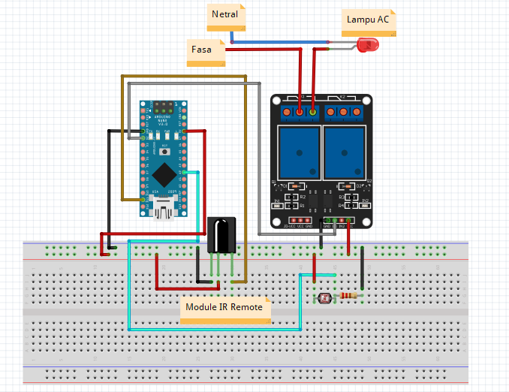

C.2 Picture of Design

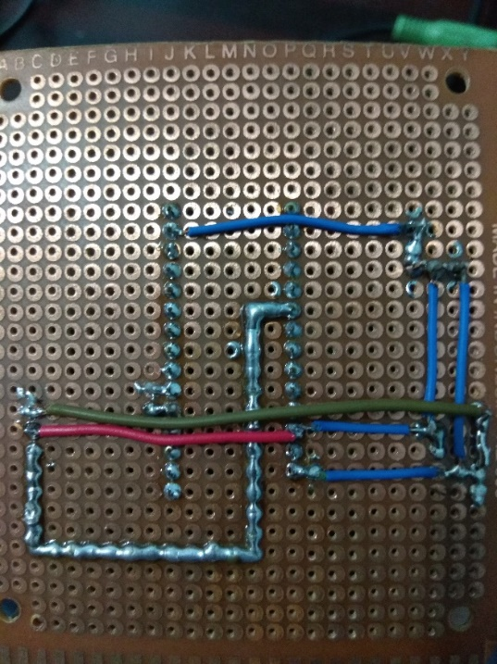

C.3 Script Program

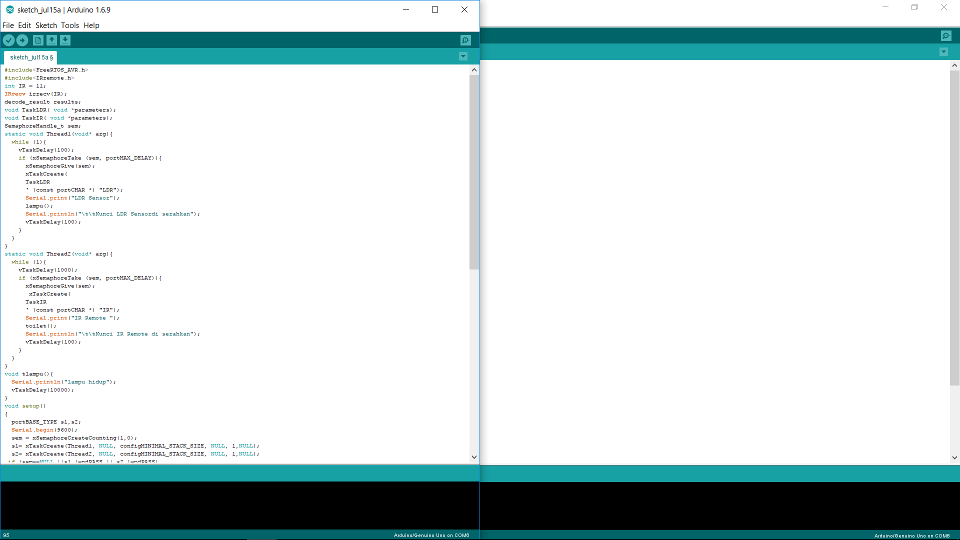

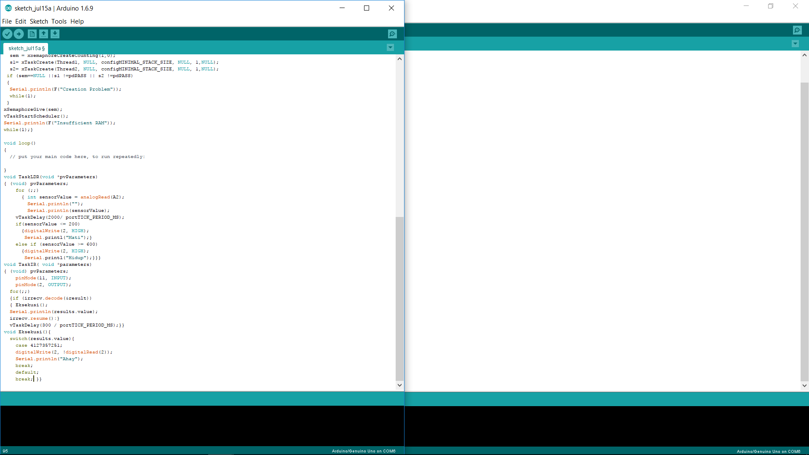

C.4 Picture of Result

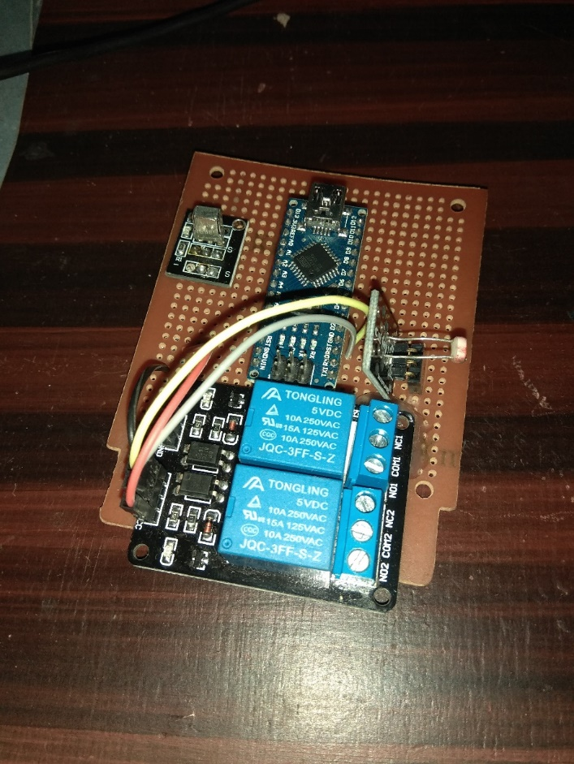

1. ANALYSIS

In this Project using Sensor LDR as automatic system to turn ON the Lamp which is connected to Relay. Remote IR is used to distract or interrupt the system to turn ON the Lamp. The Thread1 the program is the task of LDR sensor and the second priority is for Remote IR because remote IR will interrupt the system but not as the main system.

LDR sensor has value if the intensity of the light is high then the resistance will be decreasing and vice versa. So, when the high intensity light the LDR sensor will have low resitance the the lamp will be OFF and vice versa. The first attempt remote IR is to interrupt the system of automatic lamp but according to the program it’s still failed. The LDR sensor is set to turn ON the lamp when the resistance is more than equal 600 and to turn OFF is set less than 200.

1. CONCLUSION
2. For Thread 1 is the remote IR because the main system is automatic system so the sensor is the 1st priority
3. Remote IR can’t interrupt LDR sensor because it will read and always read because it is in Thread 1 then LDR sensor will active after Thread 2 works